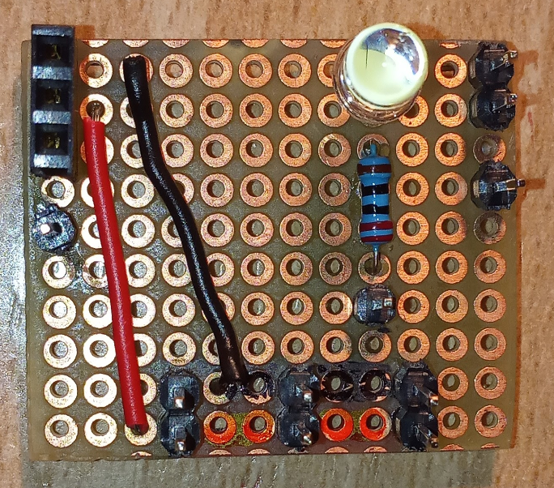

Buzzer -

Buzzer +

5V bus (powerbank output, RPi micro USB input, motor driver input)

SW pin to RPi

Push button (SW)

LED pin to RPi

Buzzer pin to RPi

Buzzer S